ZERO LAG DATA SMOOTHERS
By
John Ehlers

No causal filter can ever predict the future. As a matter of fact, the laws of nature demand that filters all must have lag. However, if we assume steady state conditions – that is, no new disturbing events – there are techniques we can use to reduce the lag of these filters to nearly zero. It turns out that such filters are useful for technical analysts to smooth data, and perhaps create some fast-acting indicators. This is possible because the steady state assumptions are almost satisfied in the short run. These techniques are not applicable to longer moving averages because steady state conditions do not continue over a long time span. There are superior techniques for creating longer term averages, such as nonlinear filters or by removing undesired cycling components from a composite price waveform.

Engineers would describe the zero lag process as the placement of a zero in the filter transfer response such that the rate change of phase at zero frequency is zero. Traders, on the other hand, can easily understand the zero lag effect as a relationship between the lag of a moving average and momentum. In Figure 1 the solid line represents a steady state price movement and the dashed line represents a moving average of the price lagging by N bars. The lag is the horizontal span. An N bar momentum has the vertical span as shown. If we add the N bar momentum to the moving average we exactly recreate the original price movement. Thus, the goal of attaining a zero lag moving average can be realized with this approach.

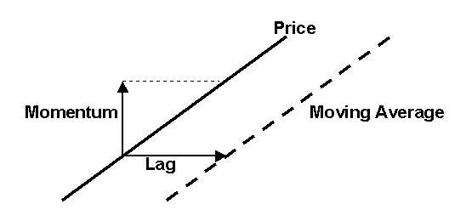

Figure 1. Steady State Lag Compensation

Lag compensation can be applied to either FIR filters (like simple moving averages) or to IIR filters (like exponential moving averages). I will apply the lag compensation technique to both types of filters, but we must first review some filter theory. The data we use in trading is sampled data. We only get the data once an hour, once a day, once a week, etc. One of the theories of sampled data is that the highest frequency we can analyze is at half the sampling frequency. If we are using daily bars, then the shortest period (that is, the highest frequency) is a 2 bar cycle. This highest frequency is called the Nyquist frequency. It is convenient to normalize all analysis to the Nyquist frequency. So, a 2 bar cycle has a normalized frequency of 1, a 4 bar cycle has a normalized frequency of 0.5, an 8 bar cycle has a normalized frequency of 0.2, and so on. The generalized equation relating the normalized frequency to cycle period is
Freq = 2 / Period or, conversely, Period = 2 / Freq

An exponential moving average works by taking a fraction of the current price and adding it to the quantity one minus the fraction times the previous filter output. The equation for an exponential moving average is
Filt = α*Price + (1-α)*Filt[1]
Where α is the fraction and [1] means that function one bar ago
Written this way, we are assured that the two coefficients sum to unity. The coefficient sum to unity is mandatory if the filter is to converge. For example, assume the price has been zero for a long time and then suddenly jumps to a value of 1. The filter output after the jump at the its input will be α on the first sample. On the next sample the filter output will be α + α *(1- α). Eventually the filter output will converge to be near unity. The lag of an exponential moving average is
Lag = 1/ α - 1

Suppose α = 0.2. In this case, lag is 4 bars. The equation for the usual exponential moving average (EMA) is
Filt = .2*Price + .8*Filt[1]
To obtain zero lag, we must add a 4 bar momentum to the input because the lag of the original EMA is 4 bars. The equation then becomes
Filt = .2*(Price + (Price – Price[4])) + .8*Filt[1]
= .2*(2*Price – Price[4]) + .8*Filt[1]

Figure 2 shows the amplitude response of the original EMA as a function of frequency and Figure 3 shows its lag as a function of frequency. Note that the greatest lag occurs at zero frequency. Lag at frequencies where the output amplitude is attenuated is unimportant because small amplitudes make little contribution to the output. By contrast, Figure 4 shows the amplitude response of the IIR zero lag data smoother and Figure 5 shows its lag as a function of frequency. The zero frequency lag has been reduced to zero. The gain, or amplification of in-band frequencies is unavoidable. The gain can be reduced, but only at the expense of adding lag again. The gain contributes to overshoot at price turning points. We will show that this small increase in gain is tolerable in practical usage.

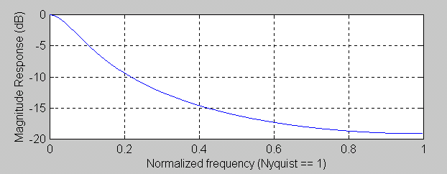

Figure 2. EMA Amplitude Response, α = 0.2

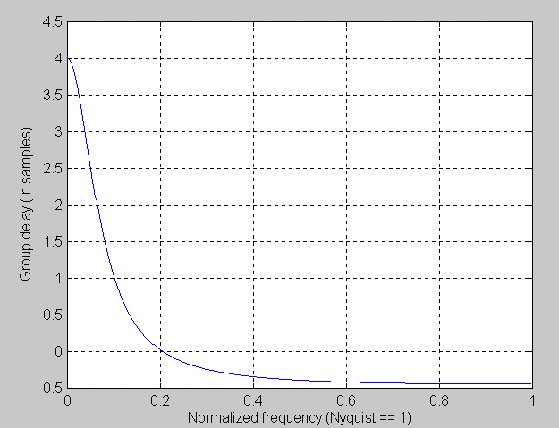

Figure 3. EMA Lag Response, a = 0.2

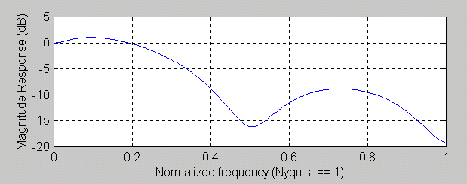

Figure 4. Zero Lag IIR Filter Amplitude Response, α = 0.2

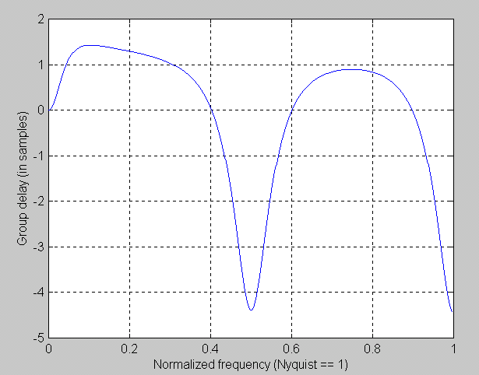

Figure 5. Zero Lag IIR Filter Lag Response, α = 0.2

My favorite FIR filter is
Filt = (Price + 2*Price[1] + 3*Price[2] + 3*Price[3] + 2*Price[4] + Price[5])/12
It is my favorite because it exactly nulls out the 2 bar, 3 bar, and 4 bar cycle components that are present in the input price. The amplitude response of this filter is shown in Figure 6. An FIR filter is a linear phase filter and lag is defined as the rate change of phase as a function of frequency. This means that FIR filters have the same lag at all frequencies, and this lag is (N-1)/2 for an N element FIR filter. Since my favorite filter has 6 elements, its lag is 2.5 bars.

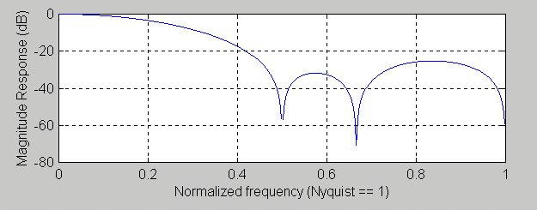

Figure 6. Six Element FIR Filter Amplitude Response

My favorite filter is already 6 bars long, and we prefer not to extend its length by another 2.5 bars when we compute the momentum. So, we will do the equivalent by multiplying a 1 bar momentum by 2.5. This is valid because we are assuming steady state conditions. We perform the calculations to compute the filter coefficients as shown in Table 1, which is equivalent to an Excel Spreadsheet. Column 1 list the coefficients of my favorite filter. Column 2 are these same coefficients delayed by 1 bar. Column 3 is the 1 bar momentum, obtained by subtracting Column 2 from Column 1 for rows that contain coefficients in Column 2. Column 4 is Column 3 multiplied by 2.5. The final filter coefficients are shown in Column 5 as the sum of the filter and the multiplied momentum (Columns 1 and 4). Therefore, the equation for the zero lag FIR filter is
Filt = (Price + 4.5*Price[1] + 5.5*Price[2] + 3*Price[3] - .5*Price[4] – 1.5*Price[5]
– 2.5*Price[6])/9.5
The filter is devided by 9.5 to normalize its output amplitude to the sum of the coefficients, providing zero gain at zero frequency.

Table 1. Computing Zero Lag FIR Filter Coefficients
Filt | Filt Lagged | Momentum | 2.5*Momentum | Zero Lag Filt
1 |  |  |  | 1
2 | 1 | 1 | 2.5 | 4.5
3 | 2 | 1 | 2.5 | 5.5
3 | 3 | 0 | 0 | 3
2 | 3 | -1 | -2.5 | -.5
1 | 2 | -1 | -2.5 | -1.5
 | 1 | -1 | -2.5 | -2.5

Several bad things happen to my favorite filter when we reduce its lag, as shown in Figure 7. First, the notch rejection of the 2 bar, 3 bar, and 4 bar cycles disappears. Second, the out of band attenuation is generally decreased. Third, there is a substantial increase in inband gain. This gain contributes to overshoots in the transient areas. But this is the price that must be paid to obtain zero lag. The lag response of the filter in Figure 8 shows that we attained our goal of zero lag at zero frequency. The large lags in the attenuation band of the filter are basically irrelevant because the amplitude of these components are reduced.

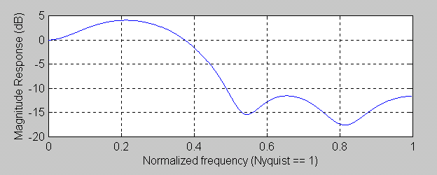

Figure 7. Zero Lag FIR Filter Amplitude Response

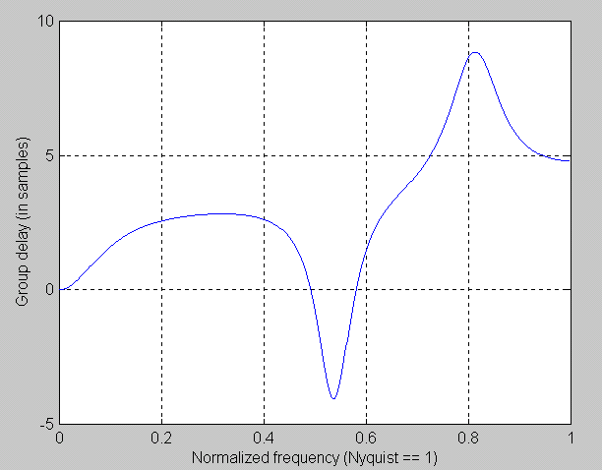

Figure 8. Zero Lag FIR Filter Lag Response

The real question of which zero lag filter is best for traders can only be answered in a comparison using real data.

Figure 9. Zero Lag IIR Filter is Preferred Because it gives less Transient Overshoot

John Ehlers, “Rocket Science for Traders”, John Wiley & Sons, Chapters 17 and 18
John Ehlers, “MESA and Trading Market Cycles Second Edition”, John Wiley & Sons, Chapter 9
John Ehlers, “MESA and Trading Market Cycles”, John Wiley & Sons, Chapter 4

